Chimera Games Engine Tutorials Tazi Mehdi

Tutorial 3 : Program Structure

Welcome to Chimera 2D Games Engine!
The Party will deal with the general structure of a program, and at the end

of this part you know how to structure your application Chimera

I) General View

First create an application Chimera
Your Source Code Should be like the picture below

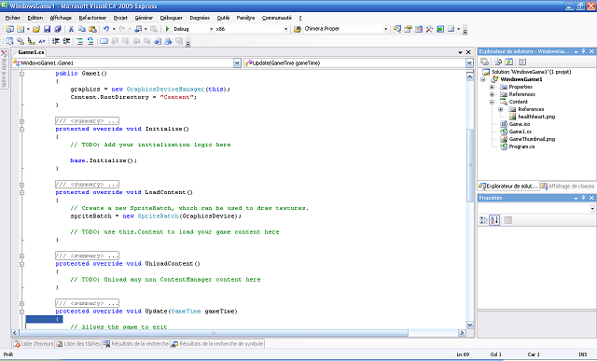

The application contains the following parts:
/ / Class Principal of our game
1)public class Game1 : Microsoft.Xna.Framework.Game

/ / Constructor By Default
2)public Game1()

/ / Initialization
3)protected override void Initialize()

/ / Loading resources
4)protected override void LoadContent()

/ / Unloading resources
5)protected override void UnloadContent()

/ / Update of components (logic of the game)
6)protected override void Update(GameTime gameTime)

/ / Display Components
7)protected override void Draw(GameTime gameTime)

- Detailed View

- Main Class

public class Game1 : Microsoft.Xna.Framework.Game

This class contains all the methods and events on Thursday
It was in this class that you go your declare variable globals

- Constructor

public Game1()

it's in the constructor that classes' will be instanced be done

- Initialization

protected override void Initialize()

In This Part We Will Initialize The Classes And Variables

- Loading Resources
protected override void LoadContent()

It is in this part that you are going to load all your resources.
Ps: resource = images, sounds, fonts, music…

- Unloading Resources

protected override void UnloadContent()

In This Party We Will Unload The Variable loaded previously

- Updating

protected override void Update(GameTime gameTime)

Party responsible for the update logic of the game
Here, for example, you will change the position of a character in order to be

moved

- Displaying

protected override void Draw(GameTime gameTime)

Part of responsible graphics rendering that is here that you will all draw your graphic objects

Voila that's it for this part; the next tutorials will be in the form of source code to make a bit of practice.

